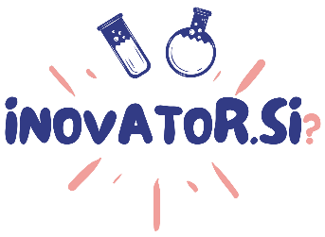

Innovative Solution Presentation
(please, insert non-confidential information only)

- Title of your solution:

………………………………………………………………………….

- The problem that your solution solves:

………………………………………………………………………….

- Short description of your solution:

………………………………………………………………………….

- Describe the advantages brought by your solution:

………………………………………………………………………….

- In which phase is your solution (planning, lab testing, prototype, product):

………………………………………………………………………….

- Have you already protected your intellectual property?

………………………………………………………………………….

